Analytical Ultracentrifugation
Practical course 2009
April 20-22th 2009 - Grenoble

http://www.ibs.fr/content/ibs_eng/information/congress/#3075

Analytical Ultracentrifugation (AUC) is a unique technique, based on rigorous thermodynamic basis, for the characterization of solution homogeneity, of macromolecule interactions, masses and shape in solution.
The aim of this course is to present to AUC users, including beginners, the principles and potent of the technique, and to provide step by step tutorials for analyzing some data, for some examples of sedimentation velocity and equilibrium, using the free available softwares Sedfit and Ultrascan developed by P. Schuck and B. Demeler, respectively.

Organisation: Christine EBEL (IBS, Grenoble)

Speakers/Tutors: Aline APPOURCHAUX (IBS, Grenoble)
Christine EBEL (IBS, Grenoble)
Bertrand RAYNAL (Institut Pasteur, Paris)
Sarah SAAB (IBS, Grenoble)

Support : Institut de Biologie Structurale IBS, Grenoble.
CEA-CNRS-Université Joseph Fourier
BECKMAN COULTER France

- Where : Polygone Scientifique, Maison des Magistères Salle LECTURE-2
- From 13H30 on 20th April 2009 to 12H30 on 22th April 2009
- Each participant brings its own laptop (PC), loaded with Sedfit & Sedphat, Ultrascan, AUC data & Excell files (instructions to be given).
- Maximum number of participants: 15 (according to registration)
- Fees: 400 Euros; no fees for academics.
- French or English language depending on participants

Inscription, related files: http://www.ibs.fr/content/ibs_eng/information/congress/#3075

Christine EBEL
Institut de Biologie Structurale, UMR 5075 CEA-CNRS-UJF
41 rue Jules Horowitz 38 027 Grenoble Cedex 1, France.
Tel: (33) 4 38 78 95 70 Fax: (33) 4 38 78 54 94
Email: christine.ebel@ibs.fr http://www.ibs.fr/

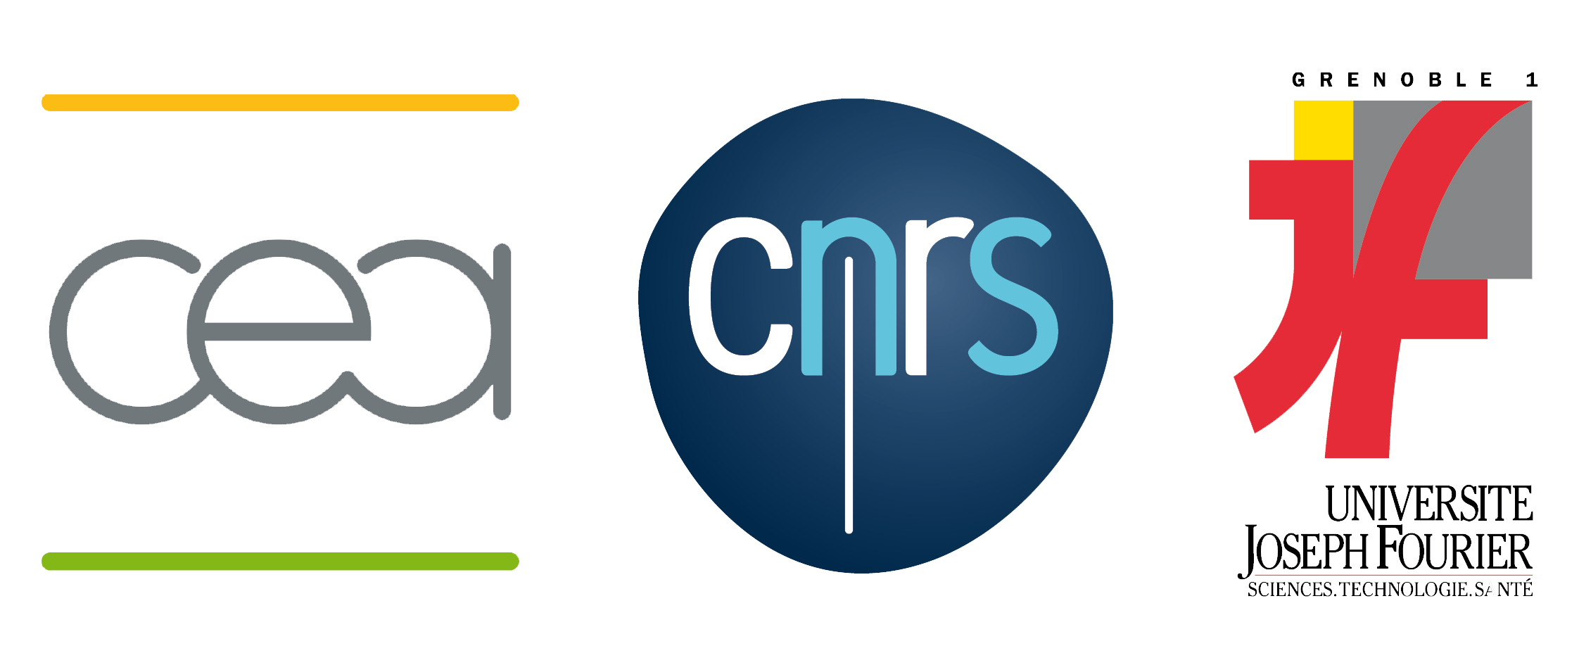

Analytical Ultracentrifugation
Practical course 2009

April 20-22th 2009 – Grenoble

http://www.ibs.fr/content/ibs_eng/information/congress/#3075

Registration :
Name, address, phone, Email: (as it will be in the list of participants)

Name and institution: (two lines, for the badge)

Practical informations:
Hotel : 10 rooms are pre-registrated: Hôtel de l’Institut, nights of 20th and 21th April (tel. : 04 76 46 36 44 ; Fax : 04 76 47 73 09 ; http://hotelinstitut.com/, Email: contact@institut-hotel.fr; at 150m from the railway station, 10 rue Barbillon38000 Grenoble). You have to confirm from you own before April 5st. Please mention « Atelier AUC 2009 », in order to have reduced price of 58 Euros TTC/night (breakfast: 7.5 Euros). Accommodation and meals are paid by participant.

- Where: Polygone Scientifique, Maison des Magistères Salle Lecture 2.
- In front of the station: Bus N°34, direction polygone scientifique (about 10 min.), stop Place de la résistance. http://physique-eea.ujf-grenoble.fr/Magistere/arch/plan-mdm.png.
- When: April 20th: welcome at 13H30; worshop: 14H00-17H30 ; April 21th : 9H00-17H30 ; April 22th 9H00-12H30.
- Needed: Each participant brings its own laptop (PC), loaded with Sedfit & Sedphat, Ultrascan, AUC data & Excell files (instructions to be given).
- Costs: 400 Euros; free for academics/students. Purchase order for the AUC Practical course at the order of CEA/IBS, to be addressed to Christine EBEL

Christine EBEL
Institut de Biologie Structurale, UMR 5075 CEA-CNRS-UJF
41 rue Jules Horowitz 38 027 Grenoble Cedex 1, France.
Tel: (33) 4 38 78 95 70 Fax: (33) 4 38 78 54 94
Email: christine.ebel@ibs.fr http://www.ibs.fr/

Analytical Ultracentrifugation
Practical course 2009
April 20-22th 2009 – Grenoble
http://www.ibs.fr/content/ibs_eng/information/congress/#3075

Speakers/Tutors: Aline APPOURCHAUX (IBS, Grenoble)
Christine EBEL (IBS, Grenoble)
Bertrand RAYNAL (Institut Pasteur, Paris)
Sarah SAAB (IBS, Grenoble)

Preliminary Programme

20th April : 13H30 : Welcome
20th April 14H00 :
Tutorial 1: Christine Ebel
Analytical Ultracentrifugation: instrument and theory
Practical I: Sarah Saab
Generating data in SEDFIT (developed by P. Schuck, USA)
Tutorial 2: Christine Ebel
Routine experiments in sedimentation velocity
Practical II: Aline Appourchaux
c(s) and non-interacting model in SEDFIT.
21th April 9H00-12h30:
Tutorial 3: Christine Ebel
Sedimentation velocity for heterogeneous systems: c(s) and ls-g*(s)
Practical III: Aline Appourchaux
- c(s) and ls-g*(s) for an heterogeneous systems in SEDFIT
Tutorial 4: Christine Ebel
Introduction to SEDPHAT (developed by P. Schuck, USA)
Practical IV: Christine Ebel
Introduction to Sedphat
21th April 14H00-17h30:
Tutorial 5: Christine Ebel
Sedimentation velocity and membrane proteins
Practical V: Christine Ebel
Analysing sedimentation velocity data for a membrane protein
Free discussion and analysis of data from the participants
22th April 9H00-12h30:
Tutorial 6: Bertrand Raynal
Sedimentation equilibrium
Practical VI: Bertrand Raynal
Analyzing some sedimentation equilibrium data using the program ULTRASCAN (developed by B. Demeler, USA)

