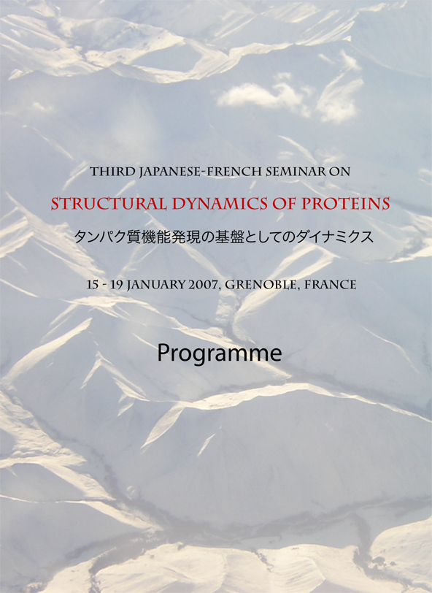

Sunday 14 January

20:30 Welcome buffet (guesthouse or ILL19)

Monday 15 January

11:00-14:00 Registration at the ESRF auditorium

14:00 Welcome and opening of the seminar at the ESRF auditorium

Session A: Protein dynamics studied by spectroscopy

14:30 F. Parak
“From fast to slow: protein dynamics on different time scales”

15:00 M. Terazima
“Studies on protein reaction dynamics in time-domain”

15:30 I. Sagi
“Structural-kinetics of metalloenzymes-application to drug design”

16:00 Coffee Break

16:30 S. Takahashi
“Detection of folding dynamics of freely flowing proteins in solution at the single molecule level”

17:00 G. Nienhaus
“Structural dynamics controls ligand binding in neuroglobin”

17:30 H. Kandori
“Discovery of strongly hydrogen-bonded water molecule that is required for the proton-pump activity of rhodopsins”

18:00 J.-L. Popot
“Stability, function and (re)folding of membrane proteins complexed by amphipathic polymers: a key underlying role for protein dynamics?”

19:30 Buffet (guesthouse or ILL19)

Tuesday 16 January

Session B: Protein dynamics and conformational changes studied by NMR

9:00 M. Blackledge
“Protein flexibility studied by partially aligned NMR spectroscopy”

9:30 K. Houben
“ Intrinsic dynamics of the partly unfolded PX domain of Sendai virus phosphoprotein, co-factor of the RNA polymerase”

10:00 L. Emsley
“Physical chemistry of crystalline proteins by solid-state NMR”

10:30 Coffee Break

11:00 R. Kitahara
“Pressure and protein dynamics”

11:30 C. van Heijenoort
“NMR multidomain proteins stability and folding analysis. Characterization of multiple states in human annexin 1 first domain using ¹⁵N relaxation dispersion experiments”

12:00 A. Mulder
“In search of the protein dynamics transition with neutron scattering and NMR spectroscopy”

12:30-14:00 Lunch ESRF-ILL canteen

Session C: Neutron spectroscopy

14:00 A. Paciaroni
“ Proteins in glassy matrices: conditioning action of the environment on the dynamics of biomolecules studied through elastic neutron scattering”

14:30 T. Hauss
“Time-resolved protein dynamics during the photocycle of bacteriorhodopsin measured in real-time by quasielastic neutron scattering”

15:00 J. Peters
“The backscattering spectrometer IN13 at the ILL (France) and selected applications”

15:30 F. Natali
“Dynamics of myoglobin in confinement: an incoherent neutron scattering study”

16:00 Coffee Break

Session D: Neutron crystallography

16:30 A. Podjarny
“Catalytic proton mobility revealed by subatomic resolution X-ray and neutron diffraction studies of fully deuterated human Aldose reductase”

17:00 M. Blakeley
“Neutron Laue diffraction for biology”

17:30 A. Ostermann
“Hydrogen atoms in myoglobin – positions and dynamics revealed by neutron structure analysis”

18:00 K. Kurihara
Neutron single-crystal diffractometers dedicated for biological macromolecules at JAEA”

19:30 Dinner in town (not organised, take bus #34 to city center)

Wednesday 17 January

Session E: X-ray crystallography to study protein intermediate states and assembly

9:00 D. Bourgeois
“Ligand migration and protein relaxation in myoglobin investigated by time- resolved Laue crystallography”

9:30 T. Nakatsu
“Structural basis for the bioluminescent color control in firefly luciferase”

10:00 J. Colletier
“Exploring the conformational energy landscape of acetylcholinesterase by kinetic crystallography”

10:30 Coffee Break

11:00 A. Royant
“Structural basis for photobleaching of a cyan fluorescent protein”

11:30 R. Ravelli
“Structural insight into microtubule dynamics”

12:00 F. Samatey
“Structure and mechanism of the flagellar universal joint”

12:30 - 14:00 Lunch ESRF-ILL canteen

Session F: Computer simulations of protein dynamics, enzyme catalysis and ligand binding

14:00 A. Kitao
“Molecular mechanism of polymorphic supercoiling: molecular dynamics study of bacterial flagellar filament and hook”

14:30 M. Field
“Molecular simulations of enzyme catalysis”

15:00 S. Hayashi
“Chemical reactions in photoreceptor and motor proteins studied by hybrid QM/MM simulations”

15:30 M. Tarek
“Voltage gated potassium channels: from structure to function - a molecular dynamics simulation study”

16:00 Coffee Break

16:30 J. Smith
“Dynamics of protein binding, reaction and structural change”

17:00 Y. Joti
“Molecular simulation study to reveal the origin of the protein boson peak”

17:30 G. Kneller
“Scaling and slow relaxation dynamics of proteins: recent results from experiments and computer simulations”

18:00 A. Kidera
“Linear response theory of structural changes upon ligand binding”

19:30 Dinner in town (not organised, take bus #34 to city center)

Thursday 18 January

Sesion G: Dynamics of hydration water and coupling to protein motions

9:00 J. Teixeira
“Liquid water: general properties, confinement and interactions at the molecular level”

9:30 M.-C. Bellissent-Funel
“Influence of hydration on protein dynamics: structure-dynamics-function relationship”

10:00 H. Nakagawa
“Hydration coupled protein dynamics studied by incoherent inelastic neutron scattering”

10:30 Coffee Break

11:00 K. Wood
“ Dynamical heterogeneity of the purple membrane: a study combining isotope labelling, neutron scattering and molecular dynamics simulations”

11:30 M. Nakasako
“Hydration structure changes around proteins at work”

12:00 M. Tehei
“Quasi-elastic neutron scattering reveals the dynamics basis of adaptation to extreme conditions”

12:30 - 14:00 Lunch ESRF-ILL canteen

SOCIAL PROGRAMME

19:30 Seminar banquet at Restaurant Pique-Pierre

Friday 19 January

Session H: Small angle X-ray and neutron scattering

8:30 M. Kataoka
“Structure of the photointermediate of photoactive yellow protein and the propagation mechanism of structural change”

9:00 R. May
“Observation of biological signal transduction dynamics with real-time neutron scattering”

9:30 S. Finet
“Dynamical properties of proteins under stress: the case of the small heat shock proteins investigated by SAXS”

10:00 Coffee Break

10:30 P. Bernado
“Structural and dynamic insights into highly flexible proteins from small-angle X- ray scattering”

11:00 M. Sato
“Low resolution structure analysis of a biological supramolecular system from
X-ray solution scattering using simulated annealing”

11:30 F. Gabel
“A novel target function for the structural refinement of macromolecular complexes in solution”

12:00 Closure

12:30 -14:00 Lunch ESRF-ILL canteen

